MAGNETS

- Magnets are materials that can attract certain materials such as iron, cobalt, nickel and some of their alloys

HISTORY OF MAGNETISM

- A shepherd had taken his sheep for grazing. He observed that the end of his stick covered with iron and the nails in his sandal got stuck to the rock.
- This led to the discovery of magnets.
- The rock came to be known as magnetite ( the name originated from the name of the shepherd Magnes or the name of the place Magnesia ) or lodestone ( lode means to attract or lead)

MAGNETIC AND NON-MAGNETIC MATERIALS

- Magnetic - attracted by a magnet
eg. iron, cobalt, nickel, al-nico ( alloy of iron, cobalt, nickel,
aluminium ; alloys are mixtures of metals with other metals or non-metals)
- Non-magnetic - materials not attracted by magnets

POLES OF MAGNET
- Poles are regions where the strength of the magnet is maximum.
- Every magnet has two poles - north pole and south pole
- Method to identify poles
Bring the magnet close to some iron fillings. The region of the magnet where the maximum amount of iron filings stick indicates the region of maximum magnetic strength and hence can be identified as the poles of the magnet. For e.g. The ends of the bar magnet are the poles.
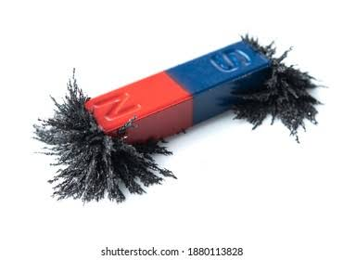

NOTE - magnetite is an example of natural magnet. Now-a-days artificial magnets are also available in different shapes as shown.
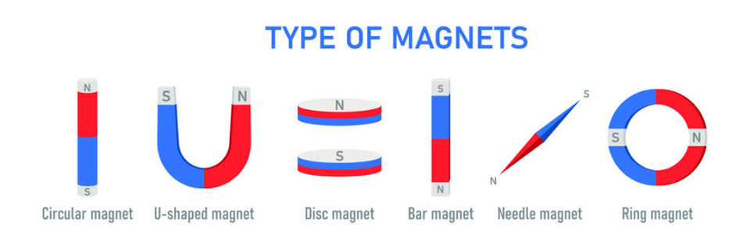

SOME PROPERTIES OF MAGNET
- Like poles repel each other and unlike poles attract each other. North-South: attraction;
- North-North: repulsion; South-South: repulsion
( REPULSION IS THE SUREST TEST FOR MAGNETISM - Since both magnetic materials and magnets can be attracted to magnets but repulsion is a property which is exclusive to magnets only)
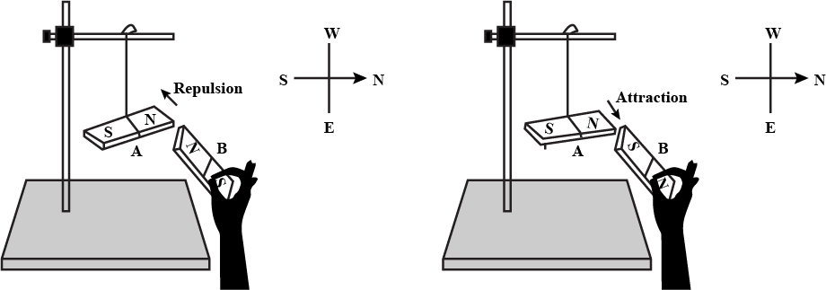
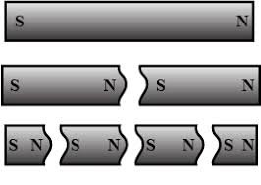
- Magnetic poles cannot be isolated.
  - Magnetic poles always exist in pairs.
  - When a magnet is broken into smaller fragments, each fragment acts as a magnet and has two poles.
  - We cannot have an isolated north pole or south pole.

DIRECTIONAL PROPERTIES OF MAGNET
- A freely suspended magnet always comes to rest in a north-south direction.
The pole which points towards the north is called the north pole or the north seeking pole. The pole which points towards the south is called the south pole or the south seeking pole.
- Reason - Earth behaves like a huge bar magnet.
Since unlike poles attract each other, the north pole of the magnet is attracted towards the earth’s magnetic south pole which is located towards the geographical north pole
Similarly, the south pole of the magnet is attracted to the earth’s magnetic north pole which is located towards the geographical south pole
- Application of directional property-MAGNETIC COMPASS
  - A small piece of magnet or a magnetic needle is allowed to rotate in a box. The north pole of the magnet is often coloured.
  - Since it is a magnet, it will come to rest in a north-south direction.
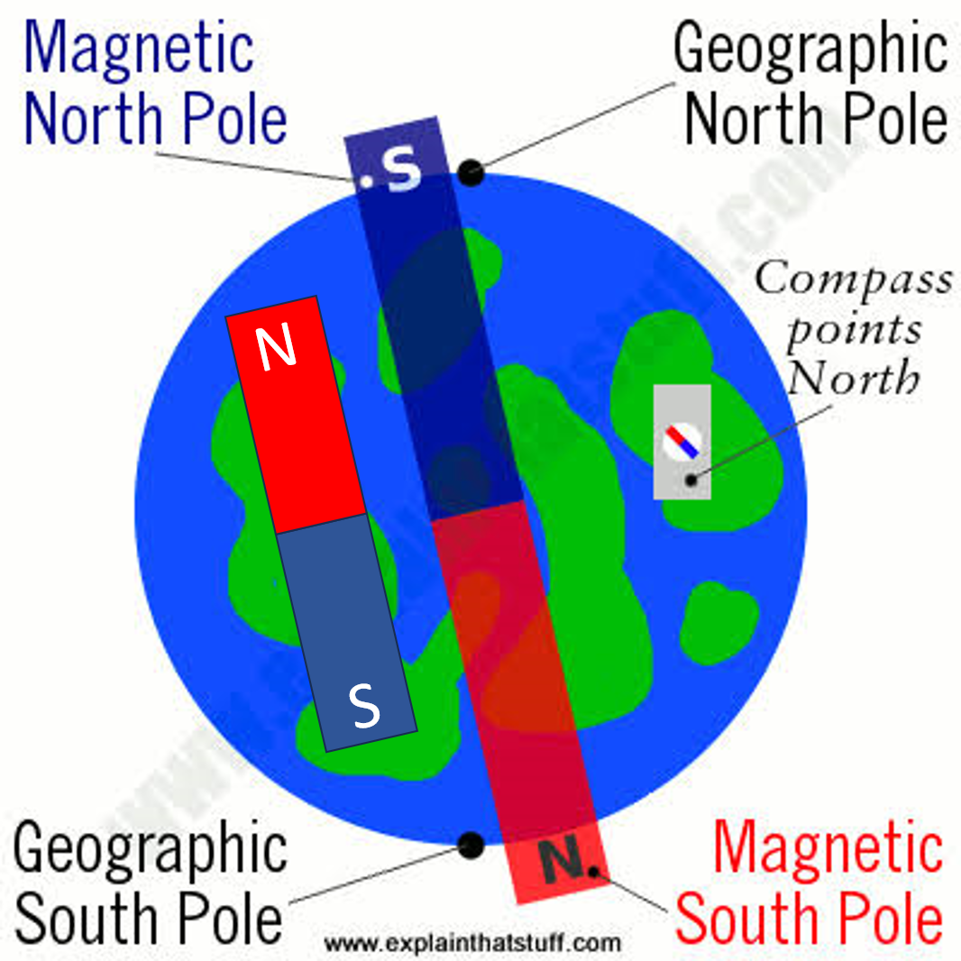

MAGNETS EXERT THEIR INFLUENCE THROUGH OTHER MEDIA-SOLID, LIQUID AND GASES

MAGNETISATION - Converting a material into a magnet
- Single stroke or Single touch method
  - An iron bar can be magnetized by repeatedly rubbing one pole of a bar magnet starting from one end along the length of the iron bar in the same direction for approx. 30 to 40 times.
  - The end of the iron bar where the magnet was initially placed will acquire the same polarity as the pole of the magnet used and the other end the opposite.
  - Produces weak magnets

- Double stroke or double touch method
  - An iron bar is magnetized by stroking it simultaneously with two opposite poles of two magnets starting from the centre towards the end, lifting them and repeating multiple times
  - Produces stronger magnets compared to single stroke method

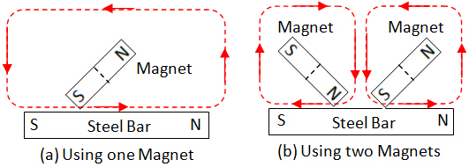

- Using Electricity
  - An electromagnet is a magnet made by using electricity.
  - Construction- A wire is coiled around a magnetic material such as an iron bar and connected to an electricity source in a circuit.
  - When the switch is on, current passes through the circuit and the iron bar is converted into a magnet.
  - The magnetism disappears when the current is switched off. Hence, this is a type of temporary magnet.
  - The strength of the magnet can be increased by passing more current.
  - The poles of the electromagnet depend on the direction of current and are reversed on changing the direction of current.
Clockwise current-South pole
Anticlockwise current-North pole
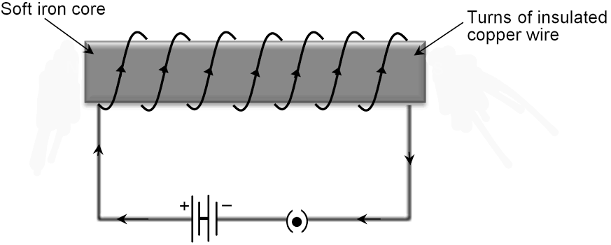
- Applications of Electromagnet
  - Used in maglev trains - the train levitates above the track due to repulsion between the track and the train.
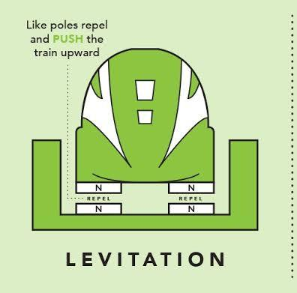
  - Used in junkyards - Cranes fitted with electromagnets are used to separate iron waste.
- Hammering gently.
DEMAGNETISATION - Reducing or destroying the magnetic properties of a magnet
- Heating Strongly
- Hammering
- Passing alternating current of high frequency.
- Rough Handling, e.g. - Dropping them repeatedly
- Natural wearing out over time - when poles are left exposed.
- Rubbing of similar poles of two different magnets lead to demagnetization
PRECAUTIONS
- Handle with care
- Don’t leave the poles exposed
- Storing magnets
  - For a bar magnet, keep two unlike poles on the same side, a block of wood in between. Keep both the ends covered with a soft iron bar.
  - For a U-shaped or horse-shoe magnet, cover the ends with an iron bar
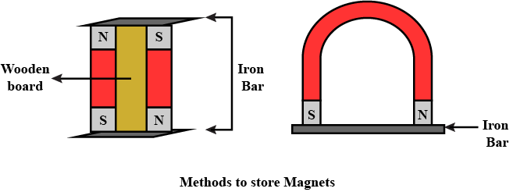

MAGNETIC FIELD - The area around the magnet where the effect of magnetism can be felt is known as a magnetic field
MAGNETIC LINES OF FORCE
- Represents magnetic force.
- They are imaginary lines which give the direction of the magnetic field.
- They start from north pole to south pole outside the magnet and south pole to north pole inside the magnet.
- Higher the density of magnetic lines of force, higher is the magnetic strength
- The density of magnetic lines of force is maximum at the poles. That is why poles have the maximum magnetic strength.
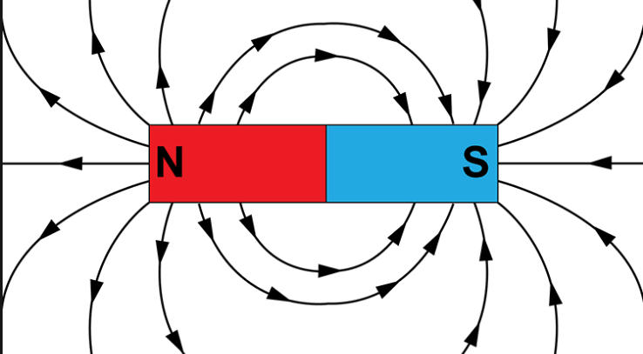
- When two opposite poles face each other, the magnetic lines of force are oriented in the same direction. Hence they attract.
- When two like poles face each other, the magnetic lines of force are oriented in the opposite direction. Hence they repel.
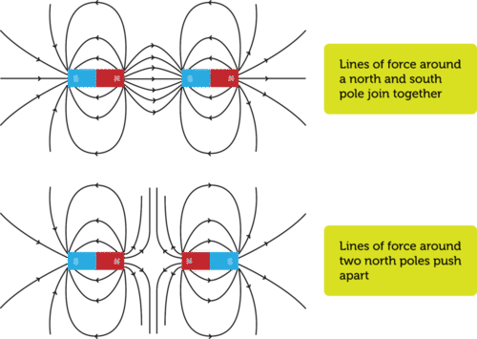

*Note: These are some points from the chapter Magnetism. Please go through your book and copy thoroughly.

